

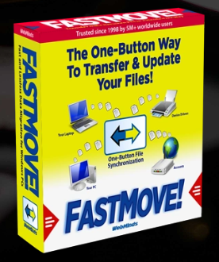

WebMinds, Inc.

TM

Version v1.0

Version

Copyright © WebMinds, Inc., 2024

All Rights Reserved

This publication is protected by federal copyright law. No part of this publication may be copied or distributed, stored in a retrieval system, or translated into any human or computer language in any form or by any means, electronic, mechanical, magnetic, manual or otherwise, or disclosed to third parties without the express written permission of **WebMinds, Inc.**

**WebMinds, Inc.** makes no representation or warranties with respect to the contents hereof and specifically disclaim any implied warranties of merchantability or fitness for a particular purpose. Further, **WebMinds, Inc.** reserves the right to revise this publication and to make changes from time to time in the contents hereof without obligation of **WebMinds, Inc.** to notify any person or organization of such revision or changes.

**WebMinds, Inc.** has prepared this guide for use by **WebMinds, Inc.** personnel and authorized third parties as a guide to proper operation and/or maintenance of **WebMinds, Inc.** equipment and software. The drawings and specifications contained herein are the property of **WebMinds, Inc.**

Trademarked names may appear throughout this user manual. Rather than list the names and entities that own the trademarks or insert a trademark symbol with each mention of the trademarked name, the names are used only for editorial purposes and to the benefit of the trademark owner with no intention of infringing upon that trademark.

Address comments and corrections to:

**WebMinds, Inc.**

950 N Collier Blvd. Suite 400

Marco Island FL 34145

USA

Revision History

|  |  |  |  |
| --- | --- | --- | --- |
| Date | Release | Revision DESCRIPTION | MODIFIED BY |
| Jan 16, 2024 | 0.1 | Initial draft | David A. Flynn |
| Jan 30, 2024 | 1.0 | First base lined user manual | David A. Flynn |
|  |  |  |  |
|  |  |  |  |
|  |  |  |  |
|  |  |  |  |

About this User Manual

This user manual contains information about all the features & functionalities of the FastMoveTM application & instructions on how to use them.

Purpose of this User Manual

The purpose of this user manual is to assist the end users of the TM application.

In Scope of this User Manual

The scope of this user manual includes the description and usage of the TM application.

Out of Scope of this User Manual

The scope of this user manual does not include –

* the detailed installation process of TM application
* the usage of the features and functionalities of your operating system

Intended Audience of this User Manual

The intended audiences of this user manual are –

* end users of the TM application

Organization of this User Manual

This user manual contains 12 chapters & 1 appendices as indicated below –

|  |  |
| --- | --- |
| chapter | Description |
| **Chapter 1** | Introduction |
| **Chapter 2** | Planning your Data Movement |
| **Chapter 3** | Placing a Register Request |
| **Chapter 4** | Placing a Buy Now Request |
| **Chapter 5** | Getting Started |
| **Chapter 6** | Performing Offline Data Migration |
| **Chapter 7** | Performing Online Data Migration |
| **Chapter 8** | Activating your FastMove TM Installation |
| **Chapter 9** | Performing Users Migration |
| **Chapter 10** | Performing Software Migration |
| **Chapter 11** | Performing Drivers Migration |
| **Chapter 12** | Performing Favorites Migration |
| **Appendix A** | Frequently Asked Questions |

Typographical Conventions / Customaries used in this User Manual

The typographical conventions used in this user manual include the following –

* **Note:** The purpose of this typographical convention is to provide important information corresponding to an already stated fact. This is how we depict a note in this user manual –

**Note:**<Note Text><Note Text><Note Text><Note Text><Note Text><Note Text><Note Text><Note Text><Note Text><Note Text><Note Text><Note Text><Note Text><Note Text>

* **Tip:** The purpose of this typographical convention is to provide additional information supplementing an already stated fact. This is how we depict a tip in this user manual –

**Tip:**<Tip Text><Tip Text><Tip Text><Tip Text><Tip Text><Tip Text><Tip Text><Tip Text><Tip Text><Tip Text><Tip Text><Tip Text><Tip Text><Tip Text><Tip Text><Tip Text><Tip Text>

* **Warning:** The purpose of this typographical convention is to provide critical information corresponding to an already stated fact. This is how we depict a warning in this user manual –

**Warning:**<Warning Text><Warning Text><Warning Text><Warning Text><Warning Text><Warning Text><Warning Text><Warning Text><Warning Text><Warning Text><Warning Text>

* **Reference:** The purpose of this typographical convention is to refer you to another section in this user manual or another document or to an external reference. A reference is depicted in the following manner in this user manual –

**Reference:** To read detailed steps, navigate to **<Chapter Name>** chapter by clicking this link.

or

**Reference:** For more information, navigate to **<Chapter Name>** chapter by clicking this link.

Abbreviations / Acronyms used in this User Manual

The table below describes the abbreviations / acronyms used in this user manual –

|  |  |
| --- | --- |
| Abbreviation | Description |
| **GUI, UI** | Graphical User Interface, User Interface |
| **IPR** | Intellectual Property Rights |
| **NO** | FastMove |
| **TM** | Trade Mark |
| **TOC, TOT, TOF** | Table of Contents, Table of Tables, Table of Figures |
| **PC** | Personal Computer |
| **FAQs** | Frequently Asked Questions |

Terms Used in this User Manual

The below table briefly describes the terms utilized in this user manual –

| chapter | Description |
| --- | --- |
| **End User** | An operator or user of the FastMove TM application. |

Table of Contents

Revision History ii

About this User Manual iii

Purpose of this User Manual iii

In Scope of this User Manual iii

Out of Scope of this User Manual iii

Intended Audience of this User Manual iii

Organization of this User Manual iii

Typographical Conventions / Customaries used in this User Manual iv

Abbreviations / Acronyms used in this User Manual v

Terms Used in this User Manual v

Table of Contents 6

Table of Figures 7

Chapter - 1. Introduction 9

1.1 Downloading the FastMoveTM Application Installer 9

Chapter - 2. Planning your Data Movement 10

Chapter - 3. Placing a Register Request 11

3.1 Via the FastMoveTM Homepage 11

3.2 Via the Register Button of FastMoveTM Application 13

Chapter - 4. Placing a Buy Now Request 15

Chapter - 5. Getting Started 17

Chapter - 6. Performing Offline Data Migration 18

Chapter - 7. Performing Online Data Migration 22

Chapter - 8. Activating your FastMoveTM Installation 27

Chapter - 9. Performing Users Migration 30

Chapter - 10. Performing Software Migration 33

Chapter - 11. Performing Drivers Migration 37

Chapter - 12. Performing Favorites Migration 41

Appendix - A. Frequently Asked Questions (FAQs) 45

Index 56

Table of Figures

Figure 1 – Downloading the FastMoveTM application installer executable file 9

Figure 2 – Placing a register request via the FastMoveTM homepage 11

Figure 3 – Specifying your registration details 11

Figure 4 – Secure cart checkout page 12

Figure 5 – Reaching the Register button in the FastMoveTM application – step 1 13

Figure 6 – Reaching the Register button in the FastMoveTM application – step 2 13

Figure 7 – Reaching the Register button in the FastMoveTM application – step 3 14

Figure 8 – Reaching the Register button in the FastMoveTM application – step 4 14

Figure 9 – Placing a buy now request via the FastMoveTM homepage 15

Figure 10 – Secure cart checkout page 16

Figure 11 – FastMoveTM default screen 17

Figure 12 – Performing offline data migration 18

Figure 13 – Selecting a folder 18

Figure 14 – Exporting you data folders & files 19

Figure 15 – Performing offline data migration 20

Figure 16 – Selecting a folder 20

Figure 17 – Importing your data files & folders 21

Figure 18 – Performing online data migration – PC1 22

Figure 19 – Performing online data migration – PC2 23

Figure 20 – Performing online data migration – PC2 23

Figure 21 – Specifying the IP Adress of your second or newer PC 24

Figure 22 – Specifying the data folders & files to migrate from your first or older PC to your second or newer PC 24

Figure 23 – Importing your data folders & files 25

Figure 24 – Selected data folders & files 25

Figure 25 – Selected data folders & files 26

Figure 26 – Reaching the Register button in the FastMoveTM application – step 1 27

Figure 27 – Reaching the Register button in the FastMoveTM application – step 2 27

Figure 28 – Reaching the Register button in the FastMoveTM application – step 3 28

Figure 29 – Specifying your FastMoveTM application license details 28

Figure 30 – Specifying your license key details 29

Figure 31 – Successful registration & activation of your FastMoveTM application license key 29

Figure 32 – Performing online data migration – PC1 30

Figure 33 – Performing online data migration – PC2 31

Figure 34 – Performing online data migration – PC2 31

Figure 35 – Specifying the IP Adress of your second or newer PC 32

Figure 36 – Specifying the users to migrate from your first or older PC to your second or newer PC 32

Figure 37 – Performing online data migration – PC1 33

Figure 38 – Performing online data migration – PC2 34

Figure 39 – Performing online data migration – PC2 34

Figure 40 – Specifying the IP Adress of your second or newer PC 35

Figure 41 – Users screen 35

Figure 42 – Importing your software 36

Figure 43 – Performing online data migration – PC1 37

Figure 44 – Performing online data migration – PC2 38

Figure 45 – Performing online data migration – PC2 38

Figure 46 – Specifying the IP Adress of your second or newer PC 39

Figure 47 – Users screen 39

Figure 48 – Importing your drivers 40

Figure 49 – Performing online data migration – PC1 41

Figure 50 – Performing online data migration – PC2 42

Figure 51 – Performing online data migration – PC2 42

Figure 52 – Specifying the IP Adress of your second or newer PC 43

Figure 53 – User screen 43

Figure 54 – Importing your favorites from your default browser 44

Figure 55 – Advanced system settings 53

Figure 56 – System Properties > User Profiles > Settings 53

Figure 57 – System Properties > User Profiles > Settings 55

# Introduction

Whether you're transferring data between computers sharing the same OS version, moving files, & settings from a Windows 7 to a Windows 11 PC, or migrating from a 32-bit to a 64-bit system, FastMoveTM is here to do the job. Using FastMoveTM to transfer data is very easy. Just connect both PCs to the network, select what you want to transfer, let FastMoveTM do the rest!

**Reference:** To view our FastMoveTM promotional video, visit <https://youtu.be/5ZBATakz8JA>

Downloading the FastMoveTM Application Installer

You can download the FastMove TM application from the **Download** link available in the menu on the FastMove TM homepage as depicted in the figure below –

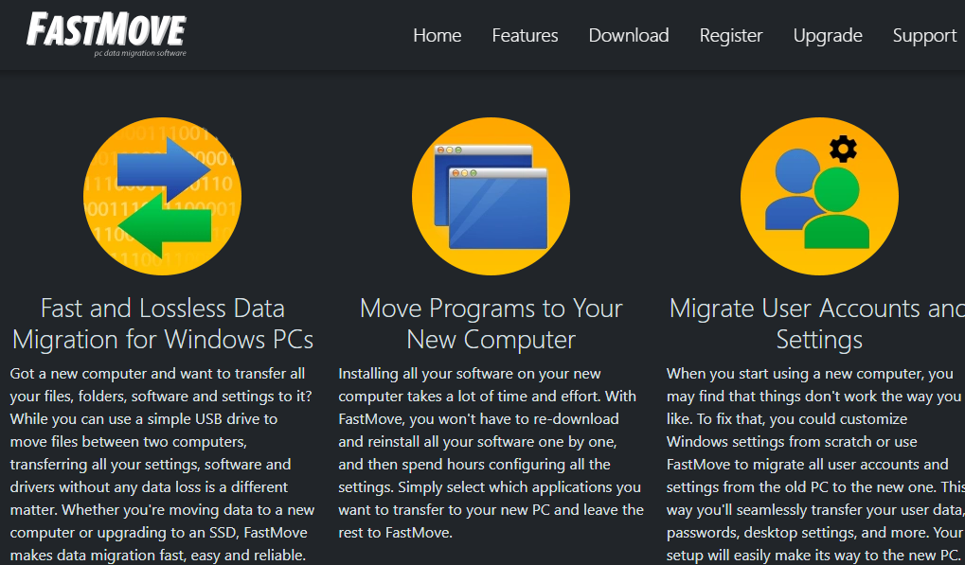

Figure – Downloading the FastMoveTM application installer executable file

**Tip:** After you click the above-mentioned links, you may be warned by your web-browser about a potential security risk due to the downloaded executable file. Please authorize this file.

You can follow the installation wizard by launching the downloaded FastMove TM installer executable file to install the FastMove TM application on both your systems.

**Tip:** After you open the downloaded executable file, you may be warned by your operating system before you can install this application on your system. Please authorize your operating system to continue installing this application at this step.

The next chapter describes steps that enable you to plan your data movement with the FastMove TM application.

# Planning your Data Movement

Since you may have just downloaded the FastMove TM installer executable file & installed this application, it is understandable that you may not have purchased a FastMove TM License Key and Registered it on both PCs as yet.

Before we go ahead, we require considering a few points as described below –

* This application will only **allow you to transfer your data files** using the **Custom Files** mode only in both the offline and online modes in the unregistered mode.
* You will not be able **to transfer your users, software, device drivers, favorites, or sync your folders** in the unregistered mode.

**Tip:** These features are only available in the registered mode.

* Also, while utilizing the offline mode, in both the registered & unregistered modes, you will also require **planning the amount of data you are expecting to move**. This is because you will require **a USB drive with enough empty storage to manually move the data between your two PCs**.
* Also, consider the scenario in the registered mode that if you are **trying to move your software from a 32-bit operating system to a 64-bit operating system**, most programs made for the **32-bit version of Windows will work on the 64-bit version of Windows except for most Antivirus programs**. Though you must **consider checking with your software manufacturers** before you make such a software movement as some of your applications may not work.

**Tip:** We highly recommend that you place a **Buy Now** or **Register** request while you test the **Custom Files** mode to save time and the least iterations of data movement.

The next chapter describes steps that enable you to **Place a Register Request** with us before you test the **Custom Files** mode the FastMove TM application. This will enable you to save time and reduce the number of iterations of your data movement.

# Placing a Register Request

You can place a **Register** request in the following 2 ways –

## Via the FastMoveTM Homepage

The steps described below enable you to place a register request of the FastMoveTM application via the FastMoveTM homepage –

1. From the FastMove TM homepage, click the **Register** link available in the menu on the FastMove TM homepage as depicted in the figure below –



Figure – Placing a register request via the FastMoveTM homepage

1. Click **Register** as depicted in the figure above. The register your software form is displayed as depicted in the figure below –

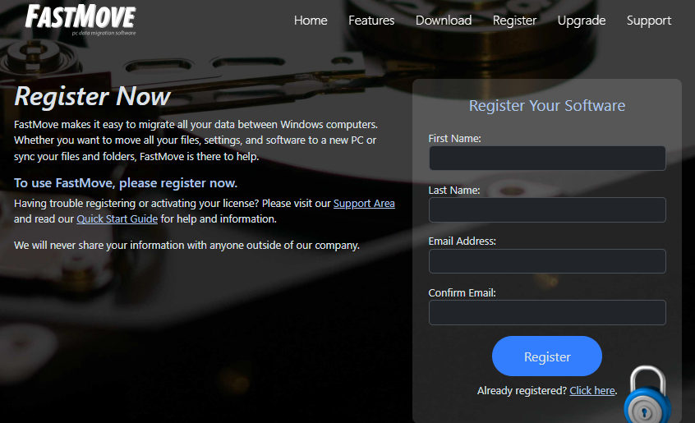

Figure – Specifying your registration details

1. Specify your first name, last name, your email address, then confirm your email address & click **Register**. The secure cart checkout page is displayed as depicted in the figure below –

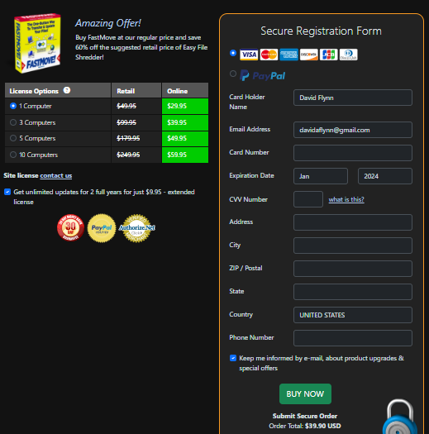

Figure – Secure cart checkout page

1. Specify the required license options and your payment details & click **Buy Now**.

**Warning:** Ensure to double-check your specified details before you click **Buy Now**.

1. Once your payment details have been successfully processed, you will receive an email containing your FastMoveTM license key.

## Via the Register Button of FastMoveTM Application

The steps described below enable you to place a register request of the FastMoveTM application via the Register Button of FastMoveTM application –

1. After you launch the FastMoveTM application, the default screen is displayed as depicted in the figure below –

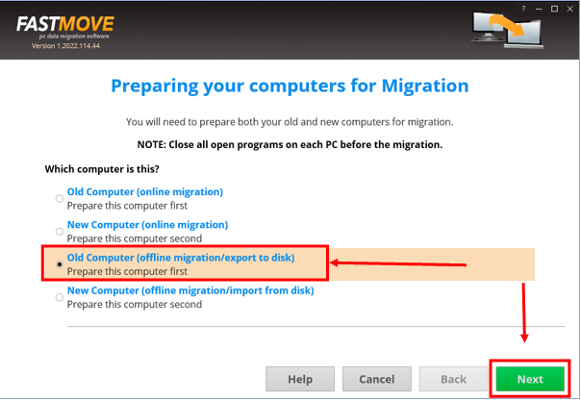

Figure – Reaching the Register button in the FastMoveTM application – step 1

1. Select the **Old Computer (offline migration/export to disk)** option & click **Next**. The folder specification page is displayed as depicted in the figure below –

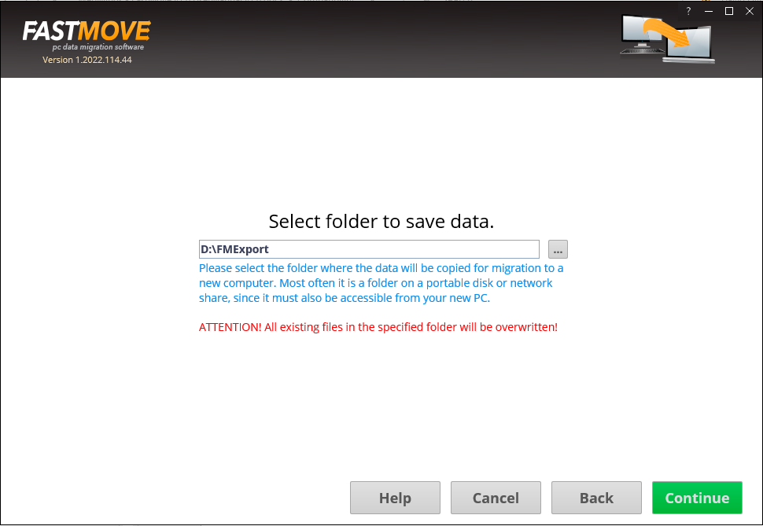

Figure – Reaching the Register button in the FastMoveTM application – step 2

1. Specify the folder to export your data by using the **Ellipsis (…)** button & click **Continue**. The custom file page is displayed as depicted in the figure below –

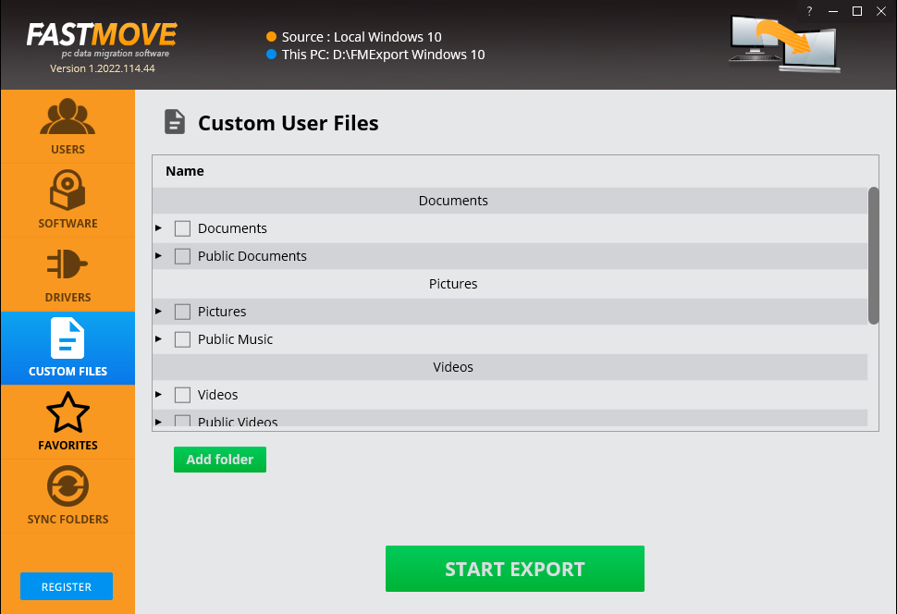

Figure – Reaching the Register button in the FastMoveTM application – step 3

1. Click the **Register** button as depicted in the figure above. The license registration key popup is displayed as depicted in the figure below –

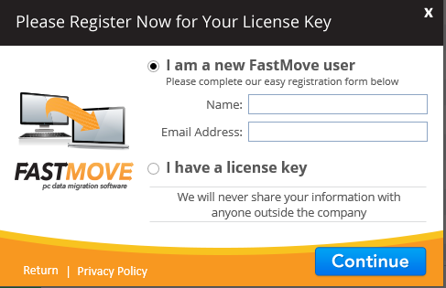

Figure – Reaching the Register button in the FastMoveTM application – step 4

1. Specify your **Name** & **Email Address** and click **Continue**. You will be redirected to the FastMoveTM Support page after which you can click **Upgrade**, specify a subscription plan of your choice, and make your payment. Post this, we will send you your license key on the email address that you specified on the registration popup.

The next chapter describes steps that enable you to **Place a Buy Now** request for a FastMove TM application key.

# Placing a Buy Now Request

The steps described below enable you to place a **Buy Now** request of the FastMoveTM application via the FastMoveTM homepage –

1. Open the FastMove TM homepage. The FastMove TM homepage is displayed as depicted in the figure below –

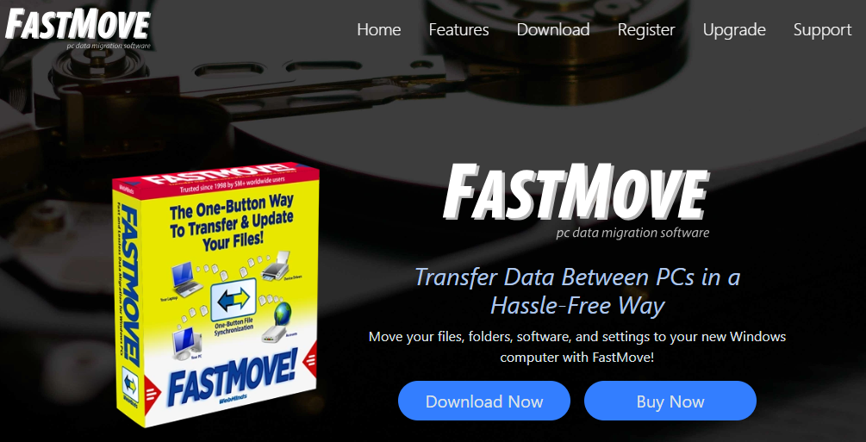

Figure – Placing a buy now request via the FastMoveTM homepage

1. Click **Buy Now** as depicted in the figure above. The secure cart checkout page is displayed as depicted in the figure below –



Figure – Secure cart checkout page

1. Specify the required license options & your payment details & click **Buy Now**.

**Warning:** Ensure to double-check your specified details before you click **Buy Now**.

1. Once your payment details have been successfully processed, you will receive an email containing your FastMoveTM license key.

The next chapter describes steps that enable you to **Get Started** with the FastMove TM application.

# Getting Started

After you launch the FastMoveTM application, the default screen is displayed as depicted in the figure below –

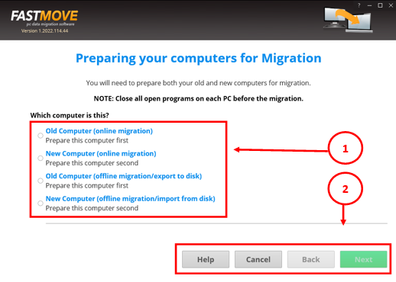

Figure – FastMoveTM default screen

Below is a description of the screen elements of the default screen of the TM application.

| **NO.** | **DESCRIPTION** |
| --- | --- |
| **1** | This section of the screen provides radio buttons to select the one the appropriate action depending on the computers. The FastMoveTM application allows to do both online and offline data, device drivers, your installed software with Zero Fault Loss Data movement in the **Registered** mode.  **Reference:** To read the detailed steps, navigate to **Activating your FastMoveTM Installation** chapter by clicking this link. |
| **2** | Clicking **Help** opens this User Manual. Clicking **Cancel** closes the FastMove TM application. Clicking **Back** enables you to revert to the previous step as you advance in the wizard. |

The next chapter describes steps that enable you to **Perform Offline Data Migration**.

# Performing Offline Data Migration

The steps described below enable you to perform offline data migration –

1. After you launch the FastMoveTM application on your first or older PC, the default screen is displayed as depicted in the figure below –



Figure – Performing offline data migration

1. Select the **Old Computer (offline migration/export to disk)** option & click **Next**. The folder specification page is displayed as depicted in the figure below –



Figure – Selecting a folder

**Tip:** Typically, this will be your external storage location.

1. Specify the folder to export your data by using the **Ellipsis (…)** button & click **Continue**. The custom file page is displayed as depicted in the figure below –



Figure – Exporting you data folders & files

1. Select the folders that you intend to export and click **Start Export**.

Tip: You can specify more folders in case they are not available in this list by clicking **Add Export**.

The specified folder will be exported to the external storage location that you specified in step 2 in this section.

1. Now attach your external storage location to your second PC and launch the FastMoveTM application.
2. After you launch the FastMoveTM application on your second or newer PC, the default screen is displayed as depicted in the figure below –

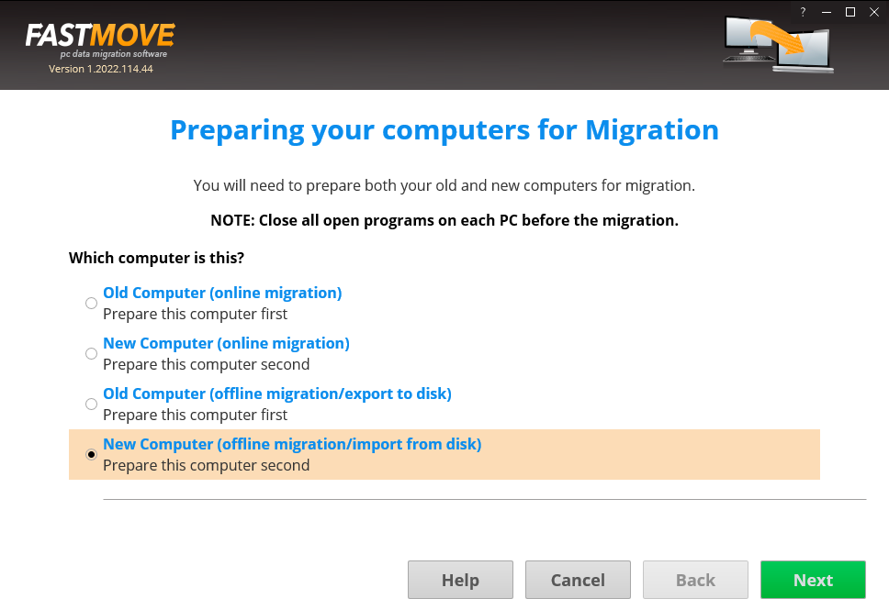

Figure – Performing offline data migration

1. Select the **New Computer (offline migration/import from disk)** option & click **Next**. The folder specification page is displayed as depicted in the figure below –

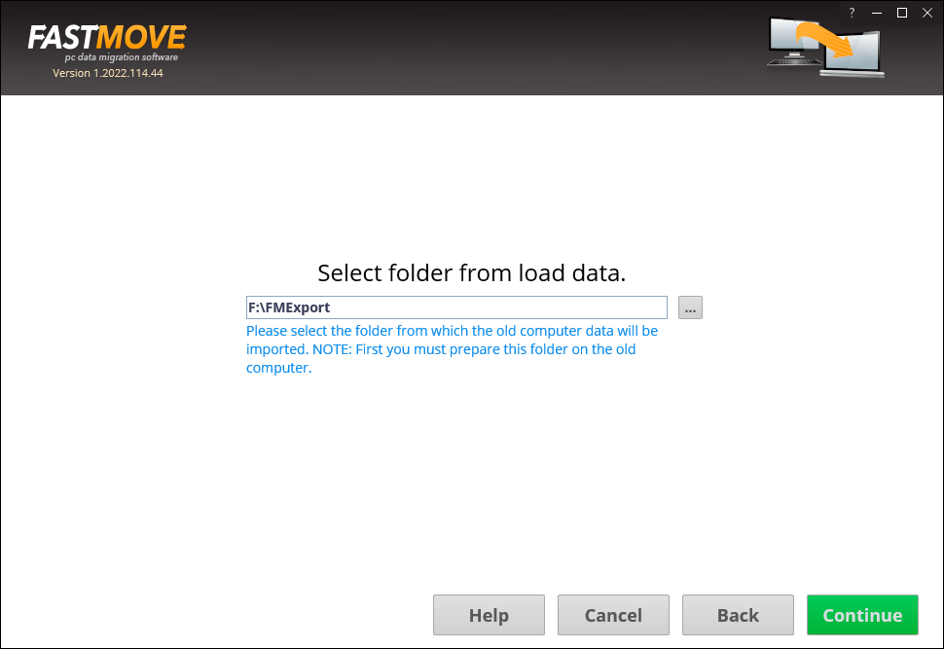

Figure – Selecting a folder

**Tip:** Typically, this will be your external storage location.

1. Specify the folder to import your data from by using the **Ellipsis (…)** button & click **Continue**. The custom file page is displayed as depicted in the figure below –

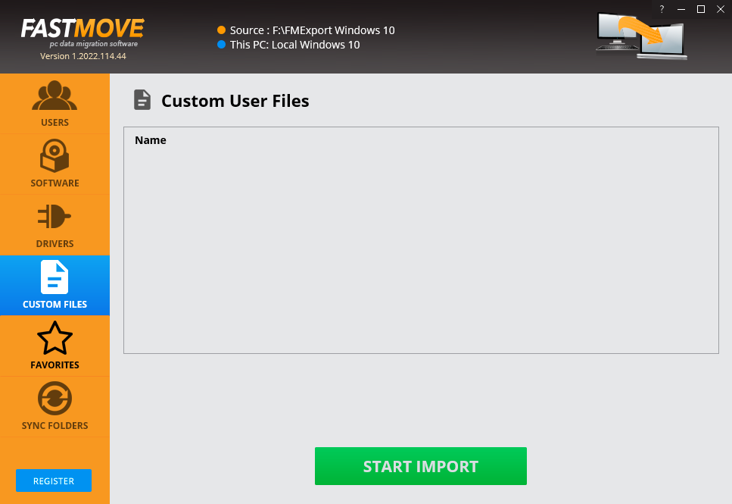

Figure – Importing your data files & folders

1. Click **Start Import**. The specified folder will be imported to you second or new PC and a confirmation message will also be displayed.

**Tip:** Your files will be imported at the same path as your first or older PC.

The next chapter describes steps that enable you to **Perform Online Data Migration**.

# Performing Online Data Migration

The steps described below enable you to perform online data migration –

1. Connect both your old & new PCs to the same network.

**Tip:** Ensure that both these PCs are discoverable to each other. Consult your network administrator or Windows Support. You may also require ensuring that you allow FastMoveTM through the Windows Firewall on both PCs.

1. After you launch the FastMoveTM application on your first or older PC, the default screen is displayed as depicted in the figure below –

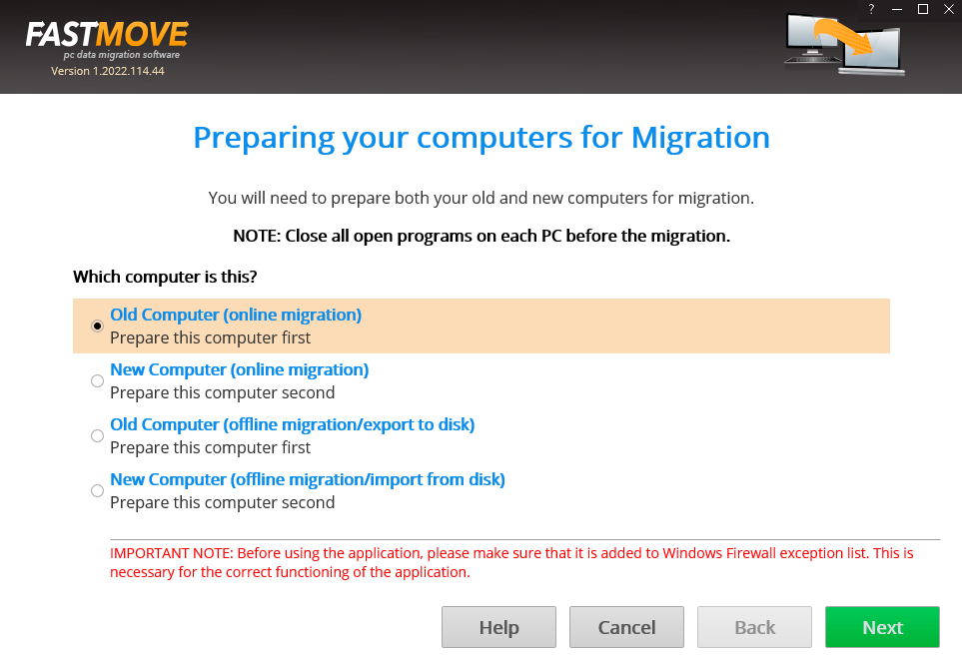

Figure – Performing online data migration – PC1

1. Select the **Old Computer (offline migration/export to disk)** option on the first or old PC & click **Next**. Your IP Address details page is displayed as depicted in the figure below –

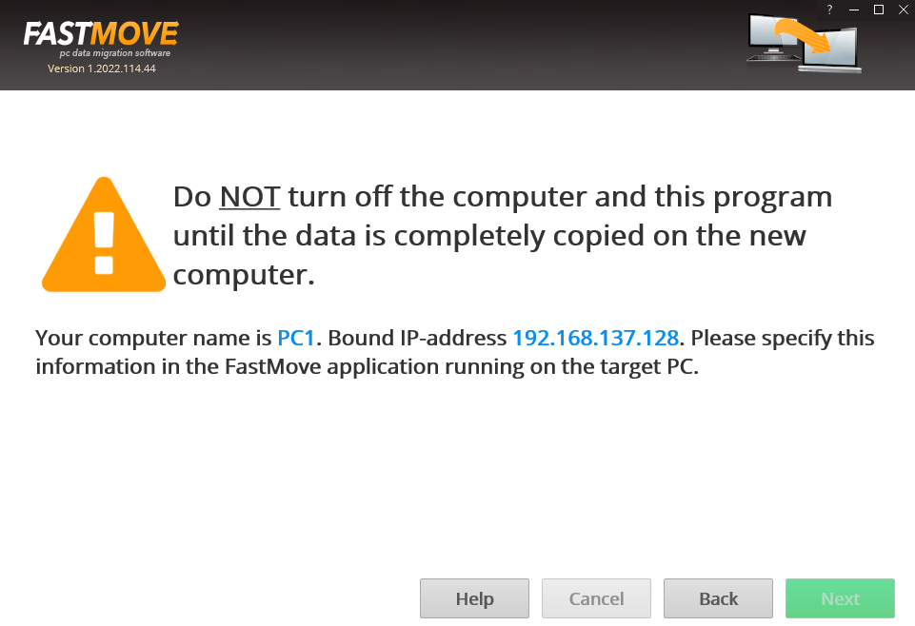

Figure – Performing online data migration – PC2

1. Now on your second or newer PC, select the **New Computer (online migration)** option & click **Next** from the default screen is displayed as depicted in the figure below –

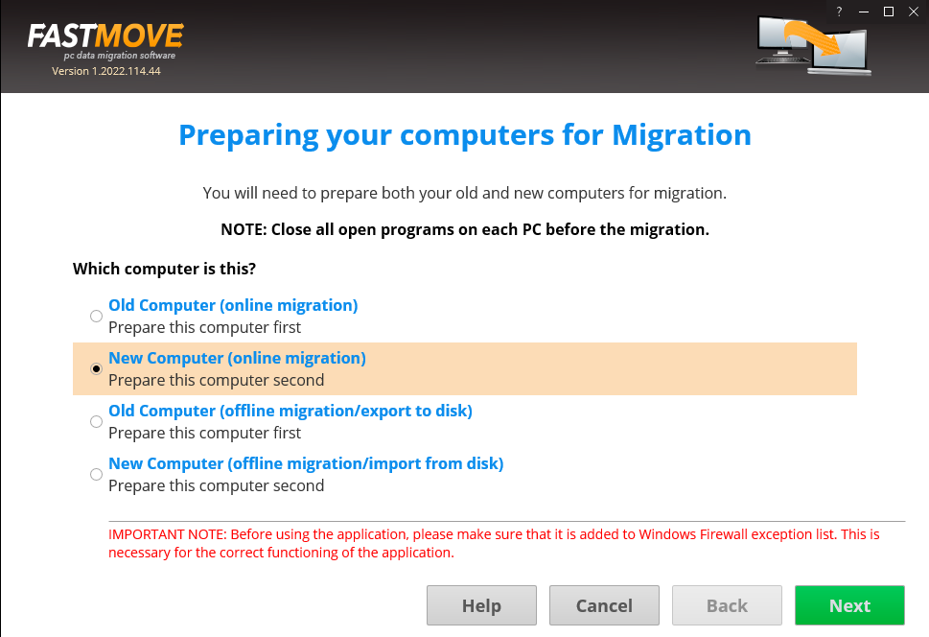

Figure – Performing online data migration – PC2

The FastMoveTM application will scan your network in order to look for your first or old PC automatically.

1. After your network has been successfully scanned, the IP Address details specification windows will be displayed as depicted in the figure below –

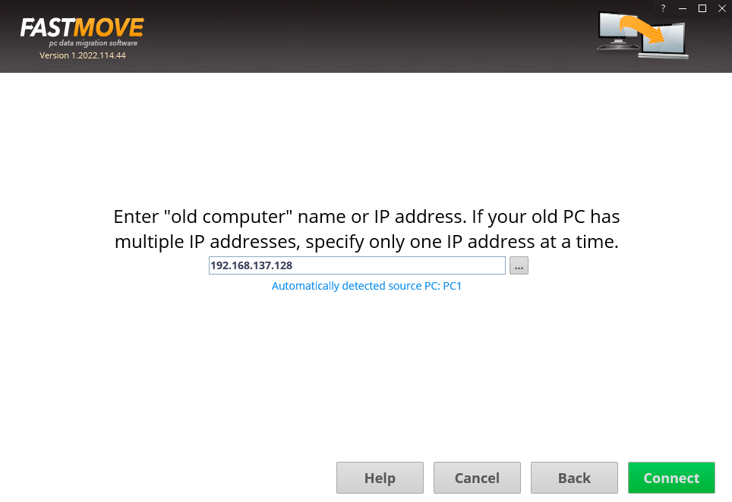

Figure – Specifying the IP Adress of your second or newer PC

**Tip:** In case you do not see an automatically detected PC, consult your network administrator or Windows Support. You can also specify another IP Address in case you have multiple PCs connected to your network via the FastMoveTM application by clicking the **Ellipses (…)** button.

1. Click **Connect**. The custom files window is displayed a depicted in the figure below –

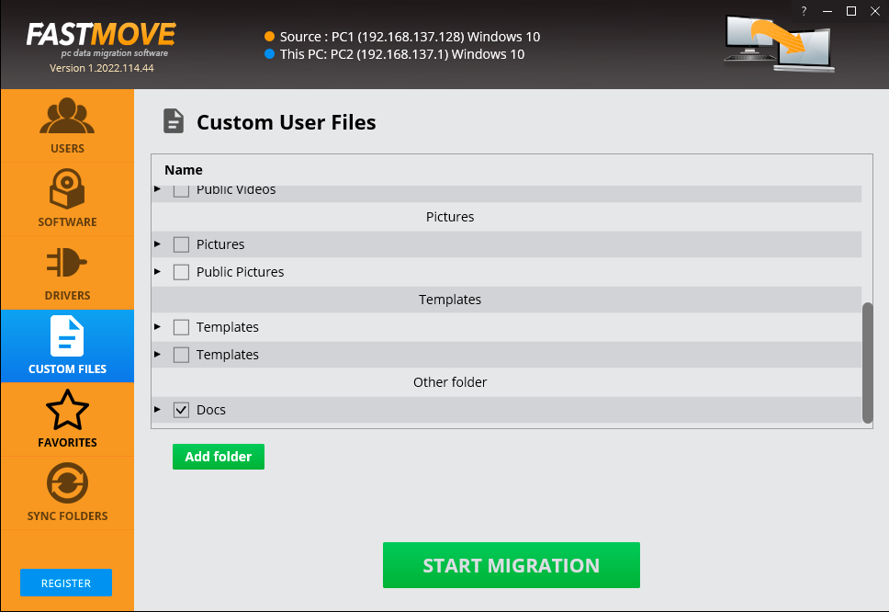

Figure – Specifying the data folders & files to migrate from your first or older PC to your second or newer PC

1. Specify the folder to import your data from this dialog box or by clicking **Add Folder** button. The custom file page is displayed as depicted in the figure below –

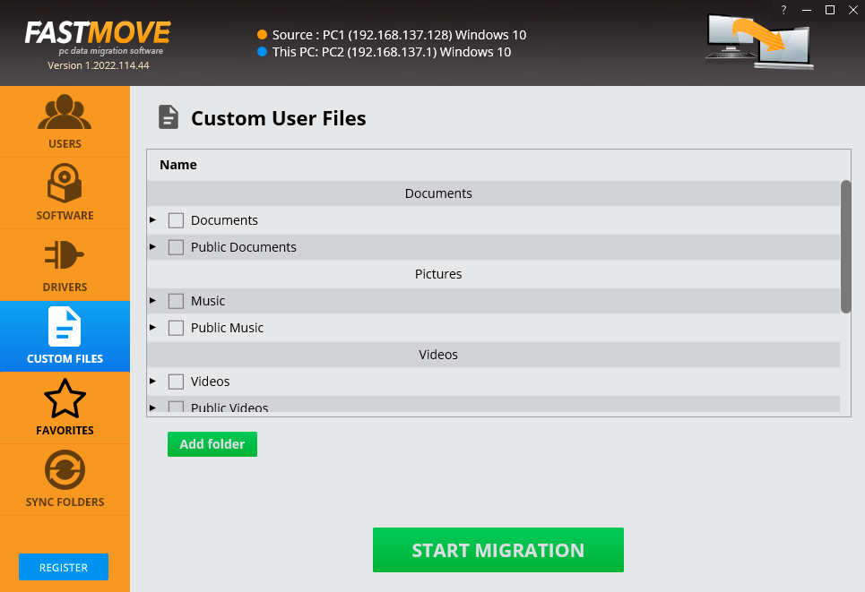

Figure – Importing your data folders & files

Your files will be selected as depicted in the figure below –



Figure – Selected data folders & files

1. Click **Start Migration**. Your data folders & files will be migrated and a confirmation message will be displayed as depicted in the figure below –

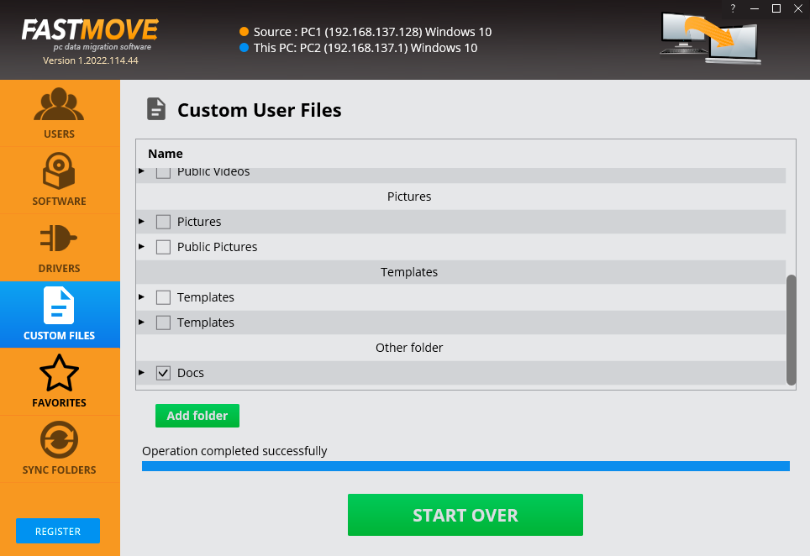

Figure – Selected data folders & files

**Tip:** You can click **Start Over** to specify more data folders or files.

The next chapter describes steps that enable you to **Activate your FastMoveTM installation**.

# Activating your FastMoveTM Installation

In case you have not activated your FastMoveTM application as yet, you can utilize the steps described below –

1. After you launch the FastMoveTM application, the default screen is displayed as depicted in the figure below –



Figure – Reaching the Register button in the FastMoveTM application – step 1

1. Select the **Old Computer (offline migration/export to disk)** option & click **Next**. The folder specification page is displayed as depicted in the figure below –



Figure – Reaching the Register button in the FastMoveTM application – step 2

1. Specify the folder to export your data by using the **Ellipsis (…)** button & click **Continue**. The custom file page is displayed as depicted in the figure below –



Figure – Reaching the Register button in the FastMoveTM application – step 3

1. Click the **Register** button as depicted in the figure above. The license registration key popup is displayed as depicted in the figure below –



Figure – Specifying your FastMoveTM application license details

1. Click **I have a License Key**. The view of this popup will change as depicted in the figure below –

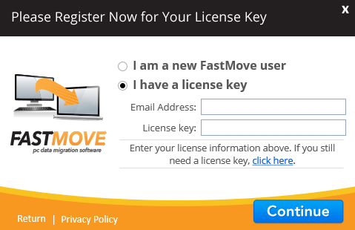

Figure – Specifying your license key details

1. Specify your **Email Address** & **License Key** and click **Continue**. After your license key has been validated successfully, a confirmation message will be displayed as depicted in the figure below –

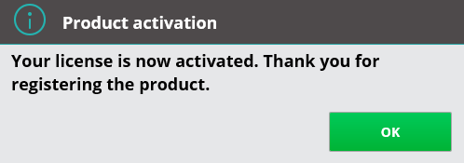

Figure – Successful registration & activation of your FastMoveTM application license key

1. Click **OK** to continue. Now your FastMoveTM application has been successfully registered and activated. Henceforth, all functionalities of this application will available to you.
2. Repeat these steps for registering & activating your FastMoveTM application installations on other PCs.

The next chapter describes steps that enable you to **Perform Users Migration**.

# Performing Users Migration

Now that you have successfully registered & activated your FastMoveTM application license key details, you can follow steps described in the **Performing Offline Data Migration** chapter to migrate your users in the offline.

The steps described below enable you to perform users migration using the online method to save time, efforts, & reduce the number of migration iterations –

1. Connect both your old & new PCs to the same network.

**Tip:** Ensure that both these PCs are discoverable to each other. Consult your network administrator or Windows Support. You may also require ensuring that you allow FastMoveTM through the Windows Firewall on both PCs.

1. After you launch the FastMoveTM application on your first or older PC, the default screen is displayed as depicted in the figure below –



Figure – Performing online data migration – PC1

1. Select the **Old Computer (offline migration/export to disk)** option on the first or old PC & click **Next**. Your IP Address details page is displayed as depicted in the figure below –



Figure – Performing online data migration – PC2

1. Now on your second or newer PC, select the **New Computer (online migration)** option & click **Next** from the default screen is displayed as depicted in the figure below –



Figure – Performing online data migration – PC2

The FastMoveTM application will scan your network in order to look for your first or old PC automatically.

1. After your network has been successfully scanned, the IP Address details specification windows will be displayed as depicted in the figure below –



Figure – Specifying the IP Adress of your second or newer PC

**Tip:** In case you do not see an automatically detected PC, consult your network administrator or Windows Support. You can also specify another IP Address in case you have multiple PCs connected to your network via the FastMoveTM application by clicking the **Ellipses (…)** button.

1. Click **Connect**. The users window is displayed a depicted in the figure below –

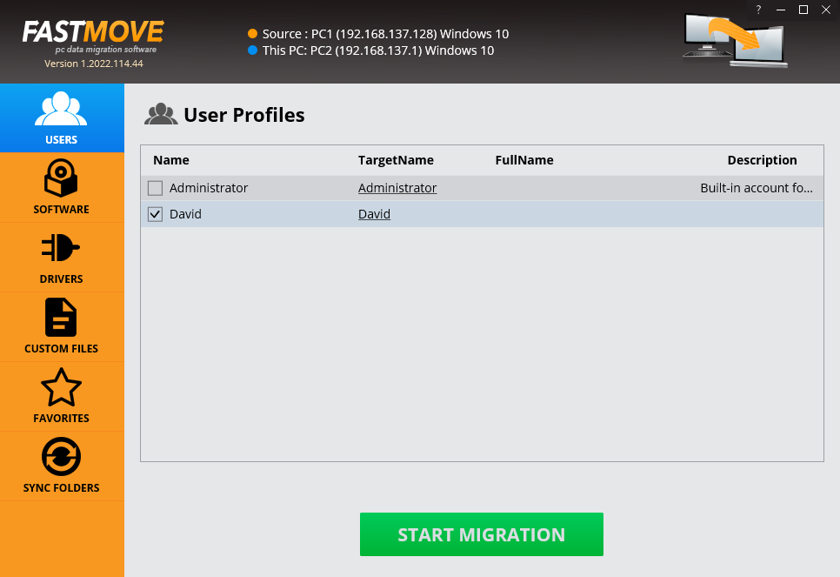

Figure – Specifying the users to migrate from your first or older PC to your second or newer PC

1. Click **Start Migration**. The selected users will be migrated & a confirmation message will also be displayed on the screen.

The next chapter describes steps that enable you to **Perform Software Migration**.

# Performing Software Migration

Now that you have successfully registered & activated your FastMoveTM application license key details, you can follow steps described in the **Performing Offline Data Migration** chapter to migrate your software in the offline mode in case you have an external storage device large enough to hold all your software.

The steps described below enable you to perform software migration using the online method to save time, efforts, & reduce the number of migration iterations –

1. Connect both your old & new PCs to the same network.

**Tip:** Ensure that both these PCs are discoverable to each other. Consult your network administrator or Windows Support. You may also require ensuring that you allow FastMoveTM through the Windows Firewall on both PCs.

1. After you launch the FastMoveTM application on your first or older PC, the default screen is displayed as depicted in the figure below –



Figure – Performing online data migration – PC1

1. Select the **Old Computer (offline migration/export to disk)** option on the first or old PC & click **Next**. Your IP Address details page is displayed as depicted in the figure below –



Figure – Performing online data migration – PC2

1. Now on your second or newer PC, select the **New Computer (online migration)** option & click **Next** from the default screen is displayed as depicted in the figure below –



Figure – Performing online data migration – PC2

The FastMoveTM application will scan your network in order to look for your first or old PC automatically.

1. After your network has been successfully scanned, the IP Address details specification windows will be displayed as depicted in the figure below –



Figure – Specifying the IP Adress of your second or newer PC

**Tip:** In case you do not see an automatically detected PC, consult your network administrator or Windows Support. You can also specify another IP Address in case you have multiple PCs connected to your network via the FastMoveTM application by clicking the **Ellipses (…)** button.

1. Click **Connect**. The users window is displayed a depicted in the figure below –

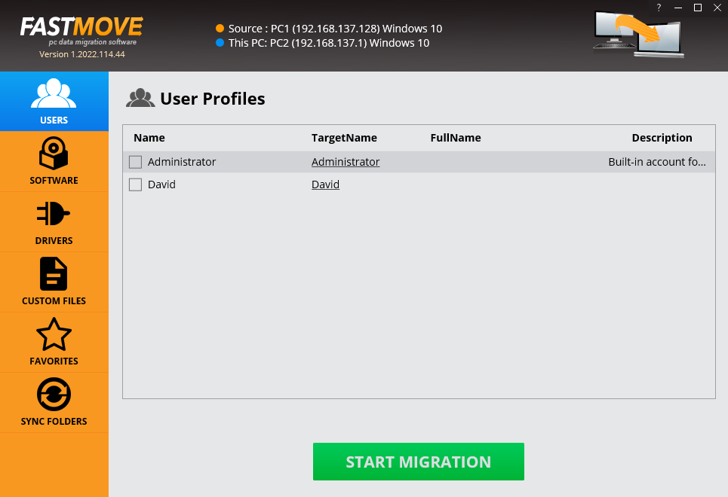

Figure – Users screen

1. Then click **Software** from the left panel. The software window is displayed as depicted in the figure below –

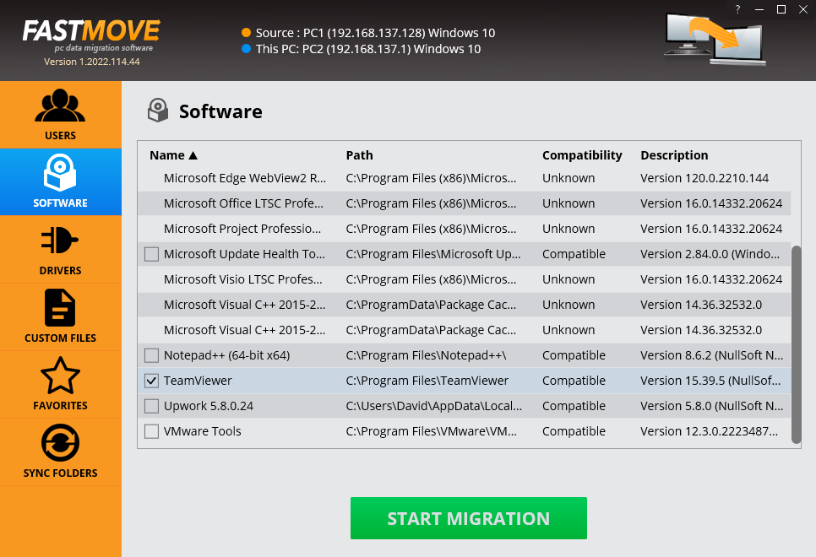

Figure – Importing your software

1. Select the software you intend to migrate & click **Start Migration**. The selected software will be migrated & a confirmation message will also be displayed on screen.

The next chapter describes steps that enable you to **Perform Drivers Migration**.

# Performing Drivers Migration

Now that you have successfully registered & activated your FastMoveTM application license key details, you can follow steps described in the **Performing Offline Data Migration** chapter to migrate your drivers in the offline mode in case you have an external storage device large enough to hold all your drivers.

The steps described below enable you to perform drivers migration using the online method to save time, efforts, & reduce the number of migration iterations –

1. Connect both your old & new PCs to the same network.

**Tip:** Ensure that both these PCs are discoverable to each other. Consult your network administrator or Windows Support. You may also require ensuring that you allow FastMoveTM through the Windows Firewall on both PCs.

1. After you launch the FastMoveTM application on your first or older PC, the default screen is displayed as depicted in the figure below –



Figure – Performing online data migration – PC1

1. Select the **Old Computer (offline migration/export to disk)** option on the first or old PC & click **Next**. Your IP Address details page is displayed as depicted in the figure below –



Figure – Performing online data migration – PC2

1. Now on your second or newer PC, select the **New Computer (online migration)** option & click **Next** from the default screen is displayed as depicted in the figure below –



Figure – Performing online data migration – PC2

The FastMoveTM application will scan your network in order to look for your first or old PC automatically.

1. After your network has been successfully scanned, the IP Address details specification windows will be displayed as depicted in the figure below –



Figure – Specifying the IP Adress of your second or newer PC

**Tip:** In case you do not see an automatically detected PC, consult your network administrator or Windows Support. You can also specify another IP Address in case you have multiple PCs connected to your network via the FastMoveTM application by clicking the **Ellipses (…)** button.

1. Click **Connect**. The users window is displayed a depicted in the figure below –



Figure – Users screen

1. Now click **Drivers** from the left panel. The drivers window is displayed as depicted in the figure below –

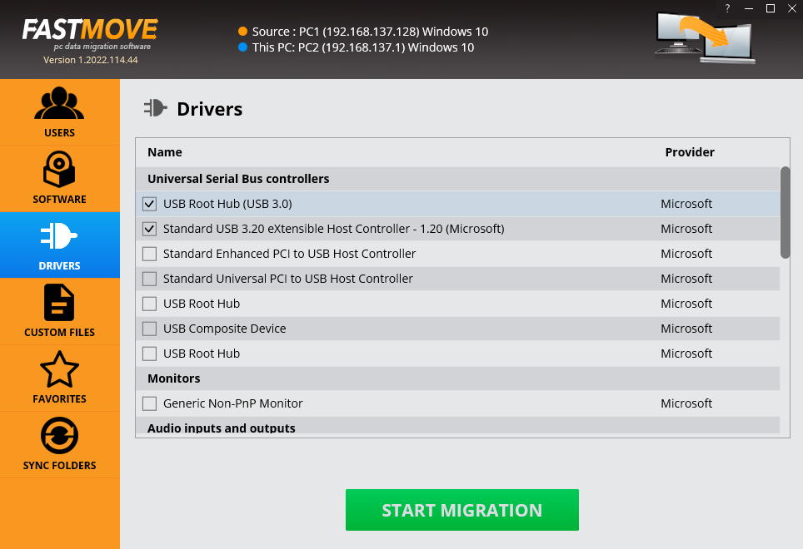

Figure – Importing your drivers

1. Select the drivers that you intend to migrate & click **Start Migration**. The selected drivers will be migrated & a confirmation message will also be displayed on screen.

The next chapter describes steps that enable you to **Perform Favorites Migration**.

# Performing Favorites Migration

Now that you have successfully registered & activated your FastMoveTM application license key details, you can follow steps described in the **Performing Offline Data Migration** chapter to migrate your favorites in the offline mode in case you have an external storage device large enough to hold all your favorites.

The steps described below enable you to perform favorites migration using the online method to save time, efforts, & reduce the number of migration iterations –

1. Connect both your old & new PCs to the same network.

**Tip:** Ensure that both these PCs are discoverable to each other. Consult your network administrator or Windows Support. You may also require ensuring that you allow FastMoveTM through the Windows Firewall on both PCs.

1. After you launch the FastMoveTM application on your first or older PC, the default screen is displayed as depicted in the figure below –



Figure – Performing online data migration – PC1

1. Select the **Old Computer (offline migration/export to disk)** option on the first or old PC & click **Next**. Your IP Address details page is displayed as depicted in the figure below –



Figure – Performing online data migration – PC2

1. Now on your second or newer PC, select the **New Computer (online migration)** option & click **Next** from the default screen is displayed as depicted in the figure below –



Figure – Performing online data migration – PC2

The FastMoveTM application will scan your network in order to look for your first or old PC automatically.

1. After your network has been successfully scanned, the IP Address details specification windows will be displayed as depicted in the figure below –



Figure – Specifying the IP Adress of your second or newer PC

**Tip:** In case you do not see an automatically detected PC, consult your network administrator or Windows Support. You can also specify another IP Address in case you have multiple PCs connected to your network via the FastMoveTM application by clicking the **Ellipses (…)** button.

1. Click **Connect**. The users window is displayed a depicted in the figure below –



Figure – User screen

1. Now click **Favorites** from the left panel. The favorites window is displayed as depicted in the figure below –

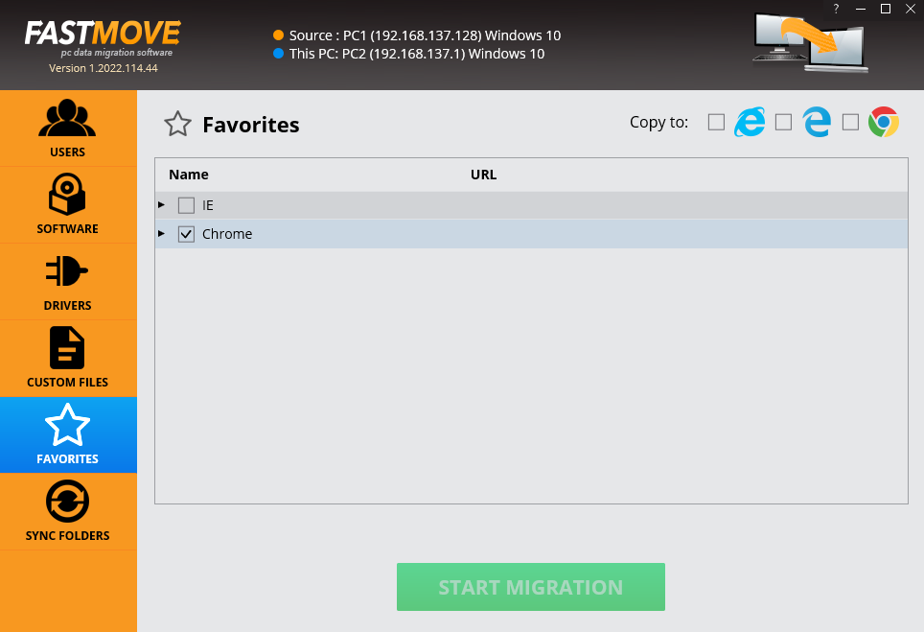

Figure – Importing your favorites from your default browser

1. Select the favorites that you intend to migrate & click **Start Migration**. Your selected favorites will be migrated & a confirmation message will be on screen.

The next section of this user manual **Frequently Asked Questions (FAQs)** as an appendix.

1. Frequently Asked Questions (FAQs)

Here is a list of frequently asked questions with reference to the FastMoveTM application and its usage –

Why do I need FastMove™?

FastMoveTM is the app that makes it easy to move all your files, user profiles, settings, software and even drivers from one computer to another. It's perfect for configuring a new computer with all your stuff, syncing folders, and keeping data and settings the same on two or more computers.

Which Operating Systems does FastMoveTM work with?

FastMoveTM supports Windows 7 - Windows 11, 32-bit and 64-bit versions. You can use it to move data between different versions of Windows operating systems. In some cases, 64-bit apps may not be compatible with a 32-bit operating system. Whenever a problem like that arises, FastMoveTM will tell you which apps couldn't be moved and why.

Can I use FastMoveTM to transfer data between Windows & Mac?

No. Currently, FastMoveTM only supports Windows operating systems.

What’s the best way to ensure that the software I moved to my new PC runs without errors?

Once you've moved your software to your new computer, run each migrated app as administrator when you use it for the first time. To do that, right-click on the program's icon and select "Run as Administrator".

Can I choose what I want to migrate?

Absolutely! You don't have to move everything from the old computer unless you want to. Use the checkboxes to select what you want to migrate and follow the app's prompts.

What does the Sync Folders feature do?

Sync Folders is a sync tool that you can use both locally and between two computers. Here's how to use it if both computers are connected to a network:

1. Select two folders you want to compare.
2. FastMoveTM will scan them and show you which files are different.
3. You can then sync the folders between both PCs.

If the computers aren't connected to the same network and you're using offline migration, do the following:

1. Select the folder you want to sync on the source PC.
2. Sync it with the offline folder you've chosen for offline migration.
3. Sync the offline folder with the desired folder on the target PC.

Can I transfer data using FastMoveTM if my computer is offline?

Yes, you can use Offline Migration:

1. First, open FastMoveTM on the computer you want to copy the data from and select the "Old Computer (offline migration/export to disk)" option, then click "Next".
2. Select a folder where you want to copy the data. Make sure the folder is located on removable media (an external hard drive or a USB thumb drive, depending on how much data you want to copy) or is a network folder. This way you will be able to access data from the target computer while offline. Once you've selected the folder, click "Continue".
3. On the next screen, select what you want to migrate using the checkboxes. When you're ready to start copying data, click on "Start Export" and wait for the export process to finish.
4. When all the data has been copied to the target folder, connect it to the computer you want to copy the data to. Then open FastMoveTM on the destination computer, select the "New Computer (offline migration/import from disk)" radio button, and select the data you want to import.

If you don't have access to an external hard drive or a network folder, you can perform offline migration with the help of a compatible USB cable that supports data transfer between two PCs:

1. Open FastMoveTM on the source computer and select a folder on that computer's hard drive where you'd like to export data.
2. Connect your old and new computers using a compatible USB cable and copy the folder with your FastMoveTM export to the new computer.
3. Open FastMoveTM on the destination computer, select the "New Computer (offline migration/import from disk)" radio button, and select the folder you've just copied you want to import.
4. Start the export and wait for FastMoveTM to finish migrating data.

**Tip:** To view detailed steps, refer to the **Performing Offline Data Migration** chapter.

Does the Sync Folder feature work in offline mode?

Yes, it works just like offline migration, which means that you'll first need to sync the folder from your Source PC with an offline folder (i.e. a folder on a removable or network drive), then connect it to the target PC and sync the offline folder with the target PC.

Can I migrate data from an HDD to an SSD using FastMoveTM?

Absolutely! FastMoveTM supports both drive types.

When I migrate software using FastMoveTM, does it also transfer license information?

No. Software licensing works in such a way that a license can't be migrated to another PC unless you have a multiple-PC license or your software supports license deactivation and reactivation. We recommend you to save your license keys and make sure you can reactivate your apps before you perform software migration.

How can I be sure that the drivers I transferred will be compatible with the new one?

When FastMove prepares device drivers for migration, it checks driver properties for a list of compatible operating systems and only transfers compatible drivers.

When I install a program on a PC, most of the times there are brand new registry updates & configuration files. Does FastMoveTM create the same registry updates & files on the new PC?

When copying user software to a new PC, FastMoveTM will only copy registry entries, folders and files created by the installer of this software. It will not remove any entries from the source PC.

If I install OEM software requiring a license & I want to move that software to a different PC, will it still be available on the source PC or will FastMoveTM remove it when it installs the software on the destination PC?

The software will still be available on the source PC because FastMove will simply COPY it to the target PC, leaving your source PC intact.

Will FastMoveTM move the emails from my email client such as Microsoft Outlook?

Yes, all your email data will be transferred as part of your user profile as long as you perform user profile migration.

What are the trial version limitations?

The trial version of FastMoveTM allows you to migrate custom files and favorites for an unlimited number of times. You'll need to purchase the full version to migrate software, users, drivers, and sync folders.

**Tip:** For more information, refer to the **Planning your Data Movement** chapter.

I want to uninstall FastMoveTM from my current PC & install it on another one using my license key. How to do it?

If you ever need to reinstall the program or move it to a different computer, you can go to the "About" screen inside the program, make a note of your license key and then remove it. This will reset the key so that you can reactivate it on a new installation (this feature is limited to 3 times).

Why is there an expiration date on my license?

When you purchase a FastMoveTM license, the license unlocks the program forever, so that you can use it for as long as you want. As for the expiry date, it's set to show you the period during which you will be able to download free updates. Once the license expires, you can continue using your version of the program, but you will need to extend your license to continue getting updates and have access to email support.

Remember that each computer is assigned a unique license ID. Once activated, the software will not work on any other computer unless you either remove the key using the "About" screen in the program.

I’m trying to register FastMoveTM but it’s not working. What to do?

There are a few things that may prevent the activation of the product, including:

* Your UAC (User Account Control) settings in Windows Vista, Windows 7, Windows 8, Windows 10 and Windows 11. When that's the case, simply close FastMove™, then right-click on its shortcut on your desktop and select "Run as administrator". Then proceed to register the program.
* Your firewall or anti-virus programs may be preventing changes to your computer. Even ones you want to make such as registering your product. Try disabling your security software temporarily and proceed with product registration.

Can I activate FastMoveTM on my old & new computer using the same license key?

Yes! Each license key is good for a pair of computers, the source PC you're copying data from and the target PC you're migrating to. For example, if you have a single FastMoveTM license, you can use it on two computers. If you purchased a license for 3 PCs, you can use it to activate FastMoveTM on 6 PCs and use the software to move data between them, and so on.

I’m trying to install FastMoveTM but my computer won’t let me. What to do?

Most likely, your computer needs you to run the installer as Administrator. Here is how you can do that:

1. Right-click on the fm_setup.exe file
2. Select "Run as Administrator..."
3. Follow the setup instructions.

I accidently closed FastMoveTM during data transfer. Will any of the files become corrupted because of that?

Don't worry, your files and other data are safe. When you accidentally close FastMoveTM during data migration, it will simply cancel the process and go back to the welcome screen where you can start data transfer again.

I was about to install FastMoveTM but I received a warning from my firewall that FastMoveTM was attempting to access the network?

FastMoveTM is a network tool, which means that it needs access to your network to work properly. Access to local area network is needed for the app to establish communication between source and target PCs. Move it to your firewall's whitelist.

I can’t seem to make online data migration work. What to do?

First of all, make sure that you have FastMoveTM installed and activated on both your old and new computers.

Secondly, check your network settings and make sure that password-protected sharing is disabled and public folder sharing is turned on. You can always change these settings back once the migration is complete.

And lastly, disable your antivirus software before migrating data to prevent it from blocking the transfer.

How to move a profile from a Windows 10 PC to a new Windows 11 PC?

* Only new users should be migrated. Otherwise, the user will lose all data related to the existing account on the target computer.
* The user profile must not exist on the target computer. If the profile exists, the user can rename the target user and/or delete it.
* The user whose profile is being transferred must log out. This means that a user must have at least two administrators to be able to migrate each other.

Can I migrate user profiles?

* FastMove enables users to migrate their profiles to a new PC, if those profiles do not already exist on the destination machine.
* FastMove safeguards against overwriting existing profiles on the target PC when the same user already exists there.

How to delete user profiles?

Customers can effortlessly remove user accounts they no longer require. Please note that only profiles of users who are not currently logged in can be deleted.

Furthermore, any user profile can be deleted through Advanced System Properties:

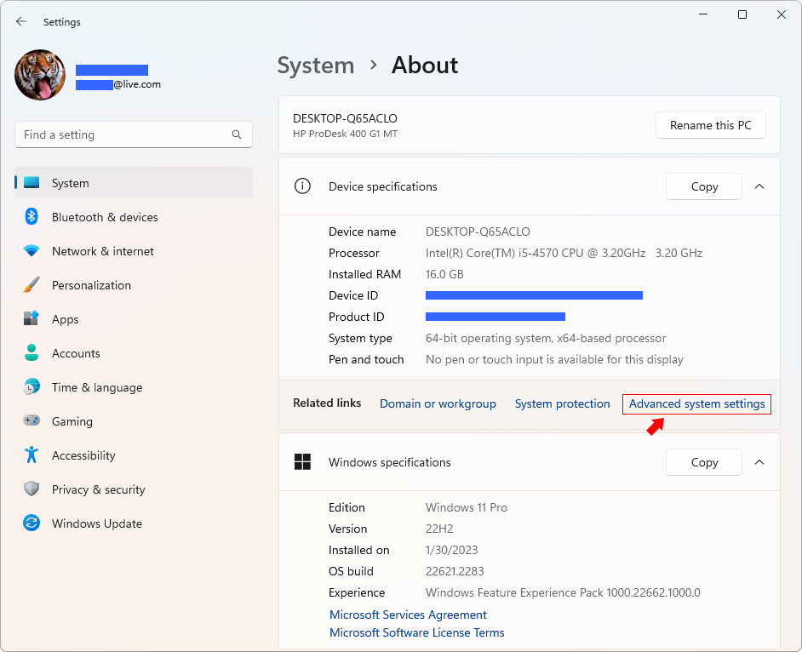

Figure – Advanced system settings

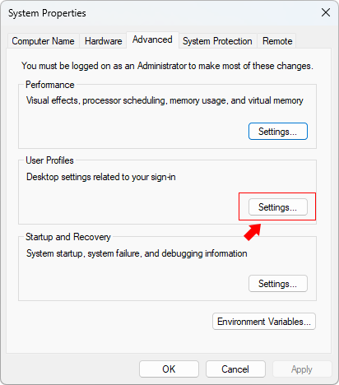

Figure – System Properties > User Profiles > Settings

Can I migrate everything all at once?

Yes, but this is not recommended. We recommend to migrate entities from one "tab" at a time: User Profiles, then Software, then Drivers (only for PC with same hardware), then Favorites, etc. The newer version will not allow to migrate everything at once to avoid issues.

Can I migrate old drivers to new PC with different hardware components?

There is no need to migrate drivers from an old system to the new hardware if that hardware does not exist on the new PC. This is only applicable to detachable hardware like Printers, Scanners and other external hardware.

Error “The password does not match the password policy criteria…”

Typically indicates that the target PC is likely part of an NT domain and/or has stringent security policies in place.

Error “The specified file was not found”

Occurred while FastMoveTM attempted to copy C:\Windows\System32\atl100.dll during software migration within the directory C:\Program Files\Druide\Connectix 10. This issue likely stems from an incorrect installation of the product (Connectix 10).

No checkbox, Unable to Select Software

Explanation: This is not supported, and FastMoveTM may encounter difficulties in transferring it accurately. This is often the case when a software employs its own custom installation engine.

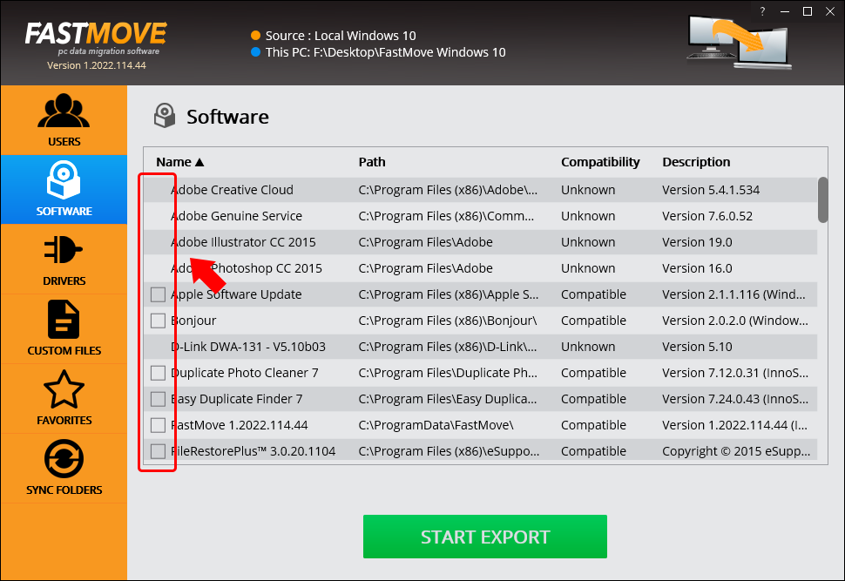

Figure 57 – System Properties > User Profiles > Settings

The next section of this user manual includes an **Index** of frequently referred terms or phrases with reference to the FastMoveTM application and its usage.

Index

A

Abbreviations / Acronyms used in this User Manual v

About this User Manual iii

Activating your FastMoveTM Installation 27

C

Can I activate FastMoveTM on my old & new computer using the same license key? 50

Can I choose what I want to migrate? 46

Can I migrate data from an HDD to an SSD using FastMoveTM? 47

Can I migrate everything all at once? 54

Can I migrate old drivers to new PC with different hardware components? 54

Can I migrate user profiles? 52

Can I transfer data using FastMoveTM if my computer is offline? 46

Can I use FastMoveTM to transfer data between Windows & Mac? 45

D

Does the Sync Folder feature work in offline mode? 47

Downloading the FastMoveTM Application Installer 9

E

Error “The password does not match the password policy criteria…” 54

Error “The specified file was not found” 54

F

Frequently Asked Questions (FAQs) 45

G

Getting Started 17

H

How can I be sure that the drivers I transferred will be compatible with the new one? 48

How to delete user profiles? 53

How to move a profile from a Windows 10 PC to a new Windows 11 PC? 52

I

I accidently closed FastMoveTM during data transfer. Will any of the files become corrupted because of that? 51

I can’t seem to make online data migration work. What to do? 51

I want to uninstall FastMoveTM from my current PC & install it on another one using my license key. How to do it? 49

I was about to install FastMoveTM but I received a warning from my firewall that FastMoveTM was attempting to access the network? 51

I’m trying to install FastMoveTM but my computer won’t let me. What to do? 50

I’m trying to register FastMoveTM but it’s not working. What to do? 50

If I install OEM software requiring a license & I want to move that software to a different PC, will it still be available on the source PC or will FastMoveTM remove it when it installs the software on the destination PC? 48

In Scope of this User Manual iii

Intended Audience of this User Manual iii

Introduction 9

N

No checkbox, Unable to Select Software 55

O

Organization of this User Manual iii

Out of Scope of this User Manual iii

P

Performing Drivers Migration 37

Performing Favorites Migration 41

Performing Offline Data Migration 18

Performing Online Data Migration 22

Performing SOFTWARE Migration 33

Performing Users Migration 30

Placing a Buy Now Request 15

Placing a Register Request 11

Planning your Data Movement 10

Purpose of this User Manual iii

T

Terms Used in this User Manual v

Typographical Conventions / Customaries used in this User Manual iv

V

Via the FastMoveTM Default Webpage 11

Via the Register Button of FastMoveTM Application 13

W

What are the trial version limitations? 49

What does the Sync Folders feature do? 46

What’s the best way to ensure that the software I moved to my new PC runs without errors? 45

When I install a program on a PC, most of the times there are brand new registry updates & configuration files. Does FastMoveTM create the same registry updates & files on the new PC? 48

When I migrate software using FastMoveTM, does it also transfer license information? 47

Which Operating Systems does FastMoveTM work with? 45

Why do I need FastMove™? 45

Why is there an expiration date on my license? 49

Will FastMoveTM move the emails from my email client such as Microsoft Outlook? 49